


Scope and Storyboard for Part 18

AMR Manchester

By SVR

Table of Contents

1 Document Revision History 2
1.1. Document Location 2
1.2. Revision History 2
1.3. Approvals 2
1.4. Distribution 2
2 Summary of Scope 3
3 Screen design 3
4 Workflow 5
5 Navigation 7
6 SQL Tables 7
7 Stored Procedures 9
8 Document Templates 9
9 Javascript Error! Bookmark not defined.

Document Revision History

Document Location
Full File Path
\\Man05sql\Dev\Applications\Flosuite\Scopes\HTMM\Scope and Storyboard Part 18\2012-07-15 FL033 Scope and Storyboard for Part 18 V0.4.doc

Revision History
Version Number | Revision Date | Summary of Changes | Changes marked | Author
0.1 | 15/07/2011 | First issue | N/A | SVR
0.2
0.3 |  | LMW amendments | Yes | LMW
0.4 | 26/07/2011 | SVR Amendments | Yes | SVR
0.5 | 09/08/2011 | SMJ Amendments | Yes | SMJ
0.6 | 12/08/2011 | SVR Comments & Minor Amendments | Yes | SVR

Approvals
Name | Signature | Title | Date of Issue | Version

Distribution
Name | Title | Date of Issue | Version

Summary of Scope

The purpose of this scope is to outline the provisions that the FloCase system will need to make to allow users to handle the process of filing a Part 18 (Further Information) questionnaire.

A Part 18 request is most likely to be part of the preparations for the defence, but may be run at any time.

It is envisioned that whilst the process itself may be of a complex nature the system should provide a simplified generic solution that merely tracks dates and has a certain amount of supervision inbuilt to assist the Team Leaders in ensuring key tasks involved in these process are dealt with in a timely manner.

  - Part 18 Description

Part 18 is described under the Civil Procedure Rules (CPR) as a request for clarification on any matter in the proceedings or a request for additional information in relation to any matter, whether or not the matter is contained or referred to in a statement of case. In practice it is a written request for the clarification or information served on the other party(ies) and/or their representatives, with a date by which the response is required.

Failure to provide a response to a Part 18 Request can lead to an application to have the matter struck-out by the court, so the response required by date is essential.

Screen design

  - : Part 18 Request

The functionality to proceed with a Defence is to be developed as part of the Scope (FL014) Defence and Allocations as a task type within the Key Dates system in FloCase. A Check-Box option to “Request Further Information (Part 18)” is to be added to this work-flow task.

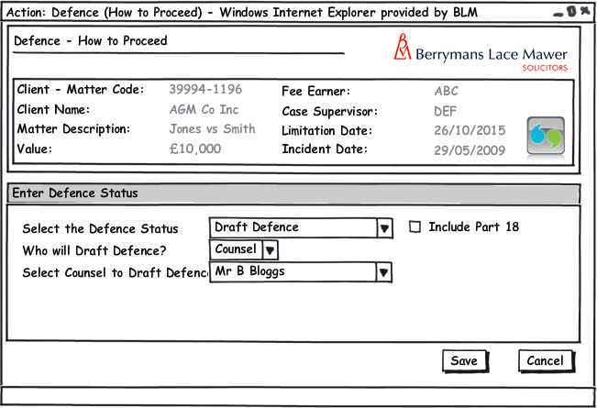

Upon selection of the Include Part 18 Check Box, a new task of Part 18 Request will be scheduled to be run when the Defence is prepared. This Task type should also be available on an Ad-Hoc basis from the Case Actions: Schedule a Task screen. On selection of the task from the Pending Tasks section or upon selection of this task from the Ad-Hoc Case Actions screen, the Part 18 Request form should be loaded:

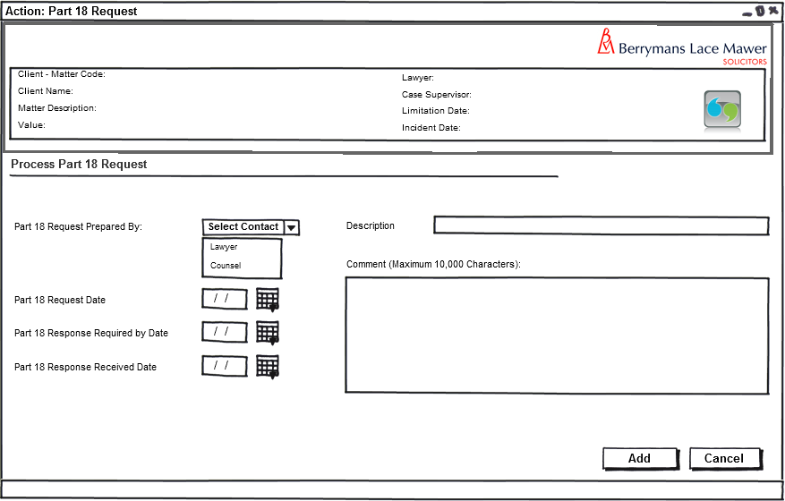

The following rules will be applicable to this form.

- The Part 18 Request Prepared By Combo Box will contain the following values from the Case Contacts Table, and will be Mandatory:
  - Lawyer
  - Counsel
  - Default to Blank
- The Part 18 Request Date should be Mandatory
- The Part 18 Response Required by Date should be mandatory if a Part 18 Request Date has been entered. Users should be able to amend this date after running the Reminder Task “Part 18 Response Due”.
- On Amendment of the Part 18 Response Due date, the system should record a history line as follows: Part 18 Response Due Date Rescheduled <<Today’s Date>> and the new Part 18 Response due Date: <<date>>
- The Part 18 Response Received Date will be optional
- The Description field should contain default text of “Part 18 Request For Further Information” but allow the user to overwrite this. The Comment Field should be free text and follow the same rules as other ad-hoc tasks’ comment fields.
- Upon execution of this task the system should create a reminder task of “Part 18 Response Due” for the date entered in the field Part 18 Response Required by Date where a date has been entered. Where a date has not been entered in this field, no reminder task should be created.

Workflow

  - Defence Preparation Part 18 Request
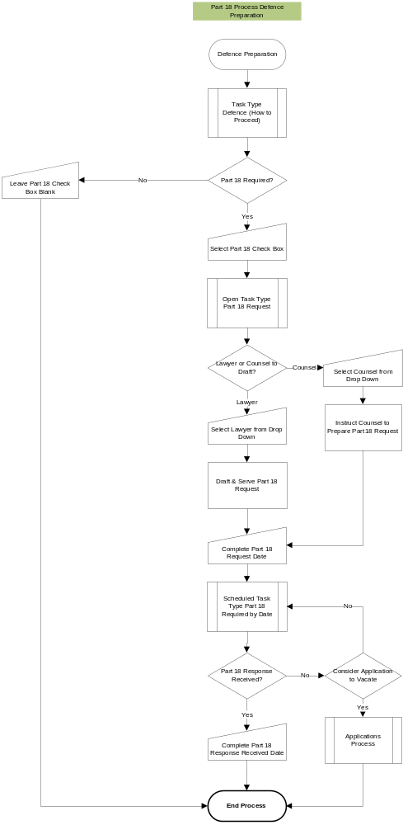

  - Part 18 Ad-Hoc Request
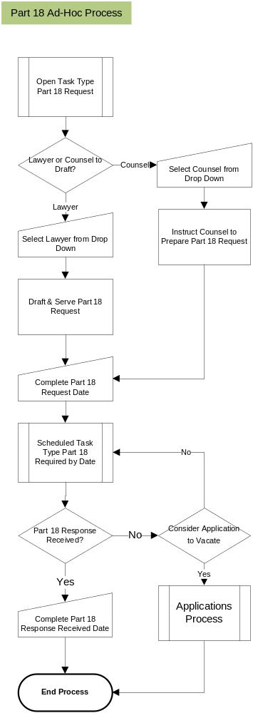

Navigation

  - Where will the Flow be launched from

Each of the flows for Part 18 Requests will be handled as Follows:
- Defence Preparation Part 18 Request – Upon the user modifying the Part 18 Request Check Box, the system will launch the defence work flow as detailed section 4.1
- Allocation – Will commence upon the user selection and running the Allocation questionnaire received activity from the Case Actions screen.
- Directions – Upon the user enter or modifying any of the direction dates on the new directions tab the system will launch the directions work flow as detailed section 4.3 specific to the Direction amended.

  - Where should the Flow return to

All work flows should return as follows:
- Defence Preparation Part 18 Request – Pending Tasks Page
- Ad-Hoc Part 18 Request – Matter Landing Page
- Part 18 Response Due – Matter Landing Page

SQL Tables

  - Table

Part18_Defence

Part18_Part18ID INT IDENTITY (1,1)
Part18_DefenceDetailsCaseID INT NOT NULL
Part18_RequestPreparedBy VARCHAR(10) NOT NULL
Part18_RequestDate DATETIME -- NOT NULL
Part18_ResponseRequiredByDate DATETIME – NOT NULL
Part18_ResponseReceivedDate DATETIME
Part18_Description VARCHAR(255) -- NOT NULL
Part18_Comment NVARCHAR(MAX) – NOT NULL
Part18_Amended BIT – NOT NULL
Part18_CreatedBy VARCHAR(255) -- NOT NULL
Part18_CreatedDate DATETIME -- NOT NULL

  - Lookup

New Lookups for ‘Request Prepared By’, having LookupTypeCode 'PrepBy':
- Lawyer
- Counsel

New KeyDatesType:
- Part 18 Response Due – Code ‘P18RespDue’
- Part 18 Response Due Date Rescheduled – Code ‘P18ReSched’

NB: AppTaskDefinition ‘KeyDate’ has already been created

  - Field

Name | Field Type | Mandatory | Rule | Form | Description
Include Part 18 | Check Box | No | Launches Part 18 Request Form | Defence – How to Proceed | Check box to record that a Part 18 Request is necessary for the defence.
Part 18 Request Prepared Date | Date | Yes | None | Part 18 Request | Date field for capturing when a Part 18 Request has been prepared
Part 18 Response Required by: | Date | Yes | None | Part 18 Request | Date Field for capturing when a response to a Part 18 Request is due by.
Part 18 Response Received | Date | No | None | Part 18 Request | Date field for capturing when a Part 18 Response has been received.

Stored Procedures

The following new stored procedures are required as follows:

  - Fetch

LTMM_Part_18_Fetch

INPUTS:
@pPart18_Part18ID INT

OUTPUTS:
DefenceDetails_Code (from DefenceDetails table)
DefenceDetails_POCRec (from DefenceDetails table)
DefenceDetails_DefStatus (from DefenceDetails table)
Part18_RequestPreparedBy
Part18_Amended
Part18_RequestDate
Part18_ResponseRequiredByDate
Part18_ResponseReceivedDate
Part18_Description
Part18_Comment
Part18_CreatedBy
Part18_CreatedDate

  - Save

LTMM_Part18_Save

INPUTS:
@pPart18_CaseID INT -- NOT NULL
@pPart18_RequestPreparedBy VARCHAR(10) -- NOT NULL - 'Lawyer' or 'Counsel'
@pPart18_RequestDate DATETIME -- NOT NULL - DEFAULT TO TODAY
@pPart18_ResponseRequiredByDate DATETIME -- NOT NULL - DEFAULT TO RequestDate + 14 DAYS
@pPart18_Description VARCHAR(255) – NOT NULL - DEFAULT 'Part 18 Response Due Today'
@pPart18_Comment NVARCHAR(MAX) -- NOT NULL – DEFAULT TO 'C'
@pPart18_Amended BIT -- NOT NULL – SET TO 1 TO CHANGE REQUIRED DATE
@pPart18_CreatedBy VARCHAR(255) -- NOT NULL - SET SYSTEM USER
@pPart18_CreatedDate DATETIME -- NOT NULL - DEFAULT TO TODAY

If @pPart18Amended = 0 THEN
- This SP will run AppTask_CreatePending

If @pPart18Amended = 1 THEN
- This SP will write a line to AppTask: ‘Part 18 Rescheduled..’, and run SP AppTask_Reschedule with new dates

Document Templates

Please list below details of any document required as part of this scope.

Status:  New / Existing / Replacement  (please state) | Received Document Name (from business) | Document File Name  (i.e. Document.dot) | Document Description  (as viewed on FloCase) | Template Description Code  (Code for auto description) | Template Group:  BLM/ Documents/ Court Doc/ Letters/ Other  (Please State)
New | Part 18 request for further information |  | Part 18 request for further information

Add new row to dmsTemplates table, filling in following rows:

- dmsTemplates_TemplateCode - TMPLT00000059
- dmsTemplates_TemplateName – Part 18 Further Information
- dmsTemplates_TemplateDesc – Part 18 Further Info
- dmsTemplates_TemplateGroup – Not known yet
- dmsTemplates_TemplatePath – Not known yet
- dmsTemplates_FormCode – NULL/BLANK
- dmsTemplates_InActive - 0
- dmsTemplates_Createuser - SMJ
- dmsTemplates_CreateDate – Date info entered
- dmsTemplates_AvailAdhoc - 1

JavaScript

/tmp/lo/0000.doc

